AirForce Management System
SQL QUERIES and Screenshorts:

Step 1: Create Database
CREATE DATABASE nexusair_crisishub;
Then connect to it:
\c nexusair_crisishub
If you're using pgAdmin, simply create the database and open the Query Tool for that database.

Step 2: Create Tables
Aircraft
CREATE TABLE Aircraft (
AircraftID SERIAL PRIMARY KEY,
AircraftType VARCHAR(100),
Capacity INT,
Status VARCHAR(50)
);

Pilot
CREATE TABLE Pilot (
PilotID SERIAL PRIMARY KEY,
PilotName VARCHAR(100),
LicenseNo VARCHAR(50) UNIQUE,
Phone VARCHAR(20),
Status VARCHAR(50)
);

Passenger
CREATE TABLE Passenger (
PassengerID SERIAL PRIMARY KEY,
FullName VARCHAR(100),
Phone VARCHAR(20),
Email VARCHAR(100)
);

Staff
CREATE TABLE Staff (
StaffID SERIAL PRIMARY KEY,
StaffName VARCHAR(100),
Role VARCHAR(50),
Phone VARCHAR(20)
);

Flight
CREATE TABLE Flight (
FlightID SERIAL PRIMARY KEY,
FlightNo VARCHAR(20),
Origin VARCHAR(100),
Destination VARCHAR(100),
DepartureTime TIMESTAMP,
ArrivalTime TIMESTAMP,
Status VARCHAR(50),
AircraftID INT REFERENCES Aircraft(AircraftID)
);

Flight_Assignment
CREATE TABLE Flight_Assignment (
AssignmentID SERIAL PRIMARY KEY,
FlightID INT REFERENCES Flight(FlightID),
PilotID INT REFERENCES Pilot(PilotID),
Role VARCHAR(50)
);
Booking
CREATE TABLE Booking (
BookingID SERIAL PRIMARY KEY,
PassengerID INT REFERENCES Passenger(PassengerID),
FlightID INT REFERENCES Flight(FlightID),
BookingDate DATE,
Status VARCHAR(50)
);

Rebooking
CREATE TABLE Rebooking (
RebookingID SERIAL PRIMARY KEY,
BookingID INT REFERENCES Booking(BookingID),
NewFlightID INT REFERENCES Flight(FlightID),
Reason VARCHAR(255),
RebookedAt TIMESTAMP
);

Disruption
CREATE TABLE Disruption (
DisruptionID SERIAL PRIMARY KEY,
FlightID INT REFERENCES Flight(FlightID),
Type VARCHAR(100),
Description TEXT,
ReportedAt TIMESTAMP,
Status VARCHAR(50)
);

Disruption_Resolution
CREATE TABLE Disruption_Resolution (
ResolutionID SERIAL PRIMARY KEY,
DisruptionID INT REFERENCES Disruption(DisruptionID),
ActionTaken TEXT,
ResolvedAt TIMESTAMP,
ResolvedBy INT REFERENCES Staff(StaffID)
);

Baggage
CREATE TABLE Baggage (
BaggageID SERIAL PRIMARY KEY,
PassengerID INT REFERENCES Passenger(PassengerID),
TagNo VARCHAR(50),
CheckInFlightID INT REFERENCES Flight(FlightID),
Status VARCHAR(50)
);

Baggage_Misdirect
CREATE TABLE Baggage_Misdirect (
MisdirectID SERIAL PRIMARY KEY,
BaggageID INT REFERENCES Baggage(BaggageID),
WrongDestination VARCHAR(100),
FoundAt VARCHAR(100),
Status VARCHAR(50)
);

Baggage_Resolution
CREATE TABLE Baggage_Resolution (
ResolutionID SERIAL PRIMARY KEY,
MisdirectID INT REFERENCES Baggage_Misdirect(MisdirectID),
ActionTaken TEXT,
DeliveredAt TIMESTAMP,
DeliveredBy INT REFERENCES Staff(StaffID)
);

Alert
CREATE TABLE Alert (
AlertID SERIAL PRIMARY KEY,
StaffID INT REFERENCES Staff(StaffID),
Message TEXT,
CreatedAt TIMESTAMP,
IsRead BOOLEAN
);

Step 3: Insert Sample Data
Run these before running feature queries.
INSERT INTO Aircraft (AircraftType, Capacity, Status)
VALUES ('Airbus A320',180,'Active');
INSERT INTO Pilot (PilotName, LicenseNo, Phone, Status)
VALUES ('Ahmed Ali','LIC001','03001234567','Available');
INSERT INTO Passenger (FullName, Phone, Email)
VALUES ('Ali Khan','03111234567','ali@gmail.com');
INSERT INTO Staff (StaffName, Role, Phone)
VALUES ('Sara Ahmed','Operations Manager','03211234567');
INSERT INTO Flight
(FlightNo, Origin, Destination, DepartureTime, ArrivalTime, Status, AircraftID)
VALUES
('PK301',
'Lahore',
'Karachi',
'2026-06-10 08:00:00',
'2026-06-10 10:00:00',
'Scheduled',
1);

Step 4: Feature Queries and Screenshots
Feature 1 – Assign Pilot
INSERT INTO Flight_Assignment
(FlightID, PilotID, Role)
VALUES
(1,1,'Captain');
SELECT* FROM pilot
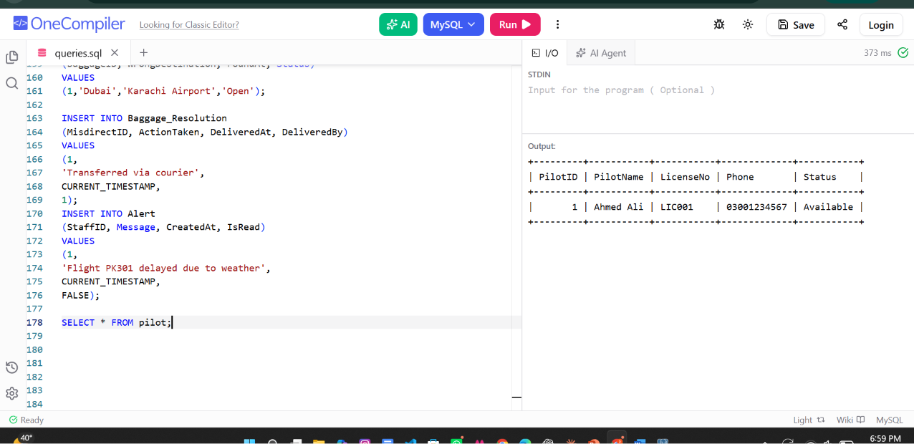

Feature 2 – Create Booking
INSERT INTO Booking
(PassengerID, FlightID, BookingDate, Status)
VALUES
(1,1,CURRENT_DATE,'Confirmed');
SELECT* FROM booking
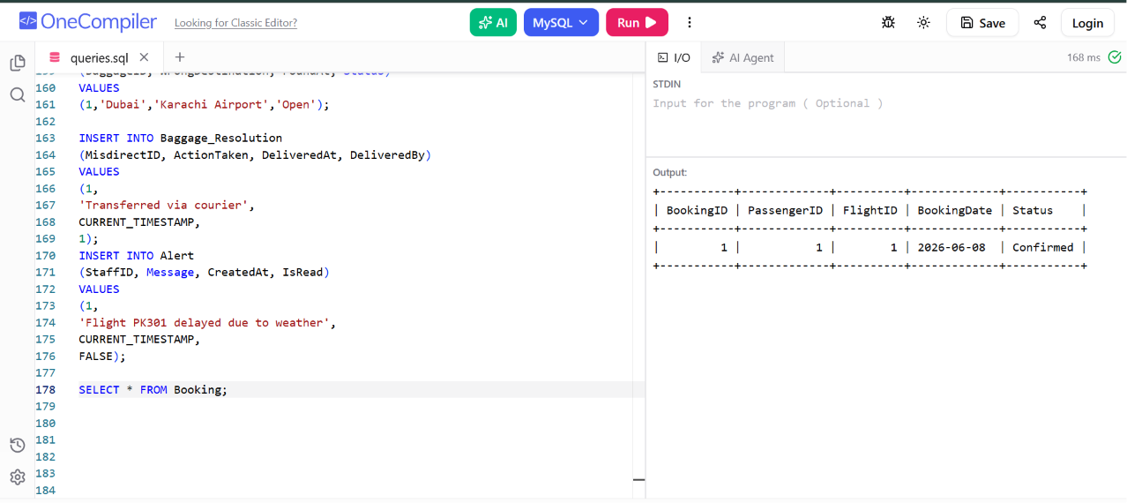

Feature 3 – Rebook Passenger
INSERT INTO Rebooking
(BookingID, NewFlightID, Reason, RebookedAt)
VALUES
(1,1,'Weather Delay',CURRENT_TIMESTAMP);
SELECT * FROM Rebooking;

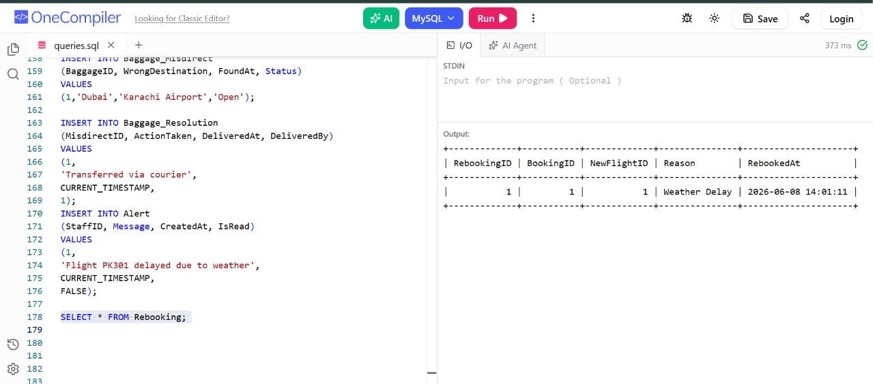

Feature 4 – Report Disruption
INSERT INTO Disruption
(FlightID, Type, Description, ReportedAt, Status)
VALUES
(1,
'Pilot Sick',
'Pilot reported illness before departure',
CURRENT_TIMESTAMP,
'Open');
SELECT * FROM Disruption;

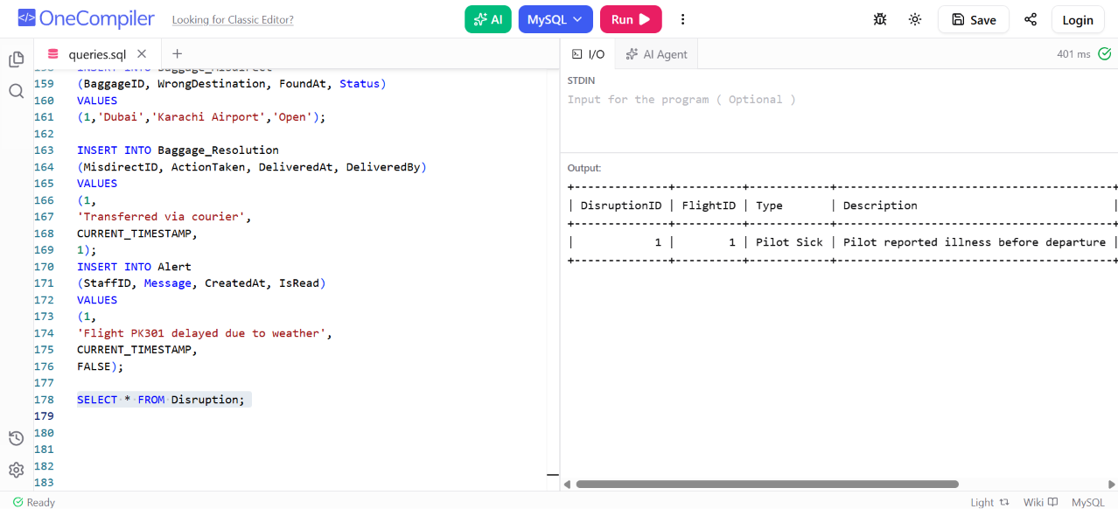

Feature 5 – Resolve Disruption
INSERT INTO Disruption_Resolution
(DisruptionID, ActionTaken, ResolvedAt, ResolvedBy)
VALUES
(1,
'Replacement pilot assigned',
CURRENT_TIMESTAMP,
1);
SELECT * FROM Disruption_Resolution;

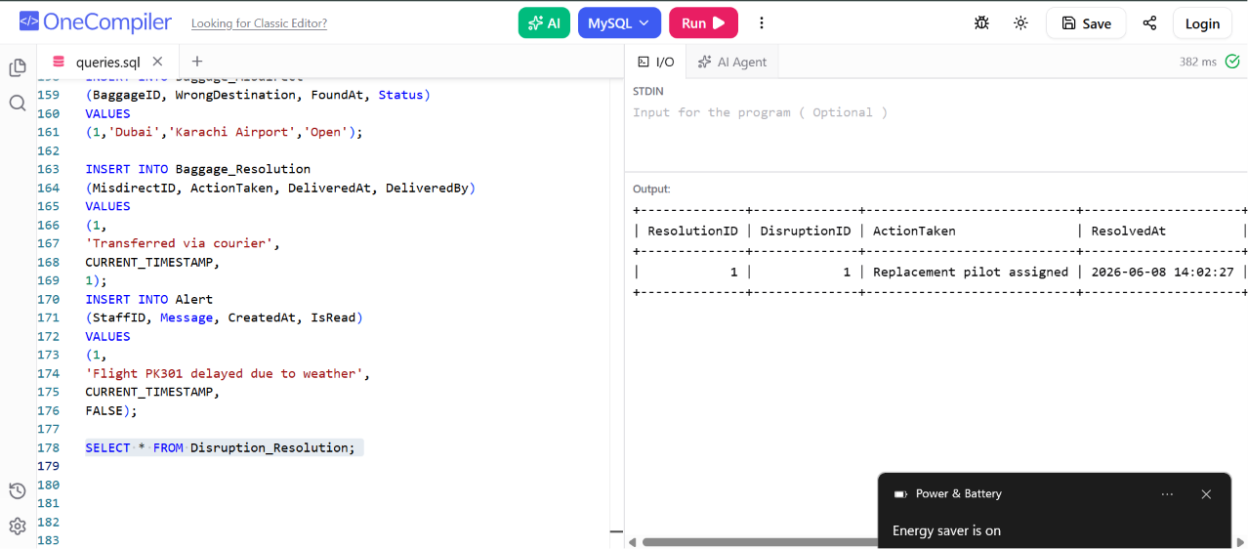

Feature 6 – Add Baggage
INSERT INTO Baggage
(PassengerID, TagNo, CheckInFlightID, Status)
VALUES
(1,'BG1001',1,'CheckedIn');
SELECT * FROM Disruption_Resolution;

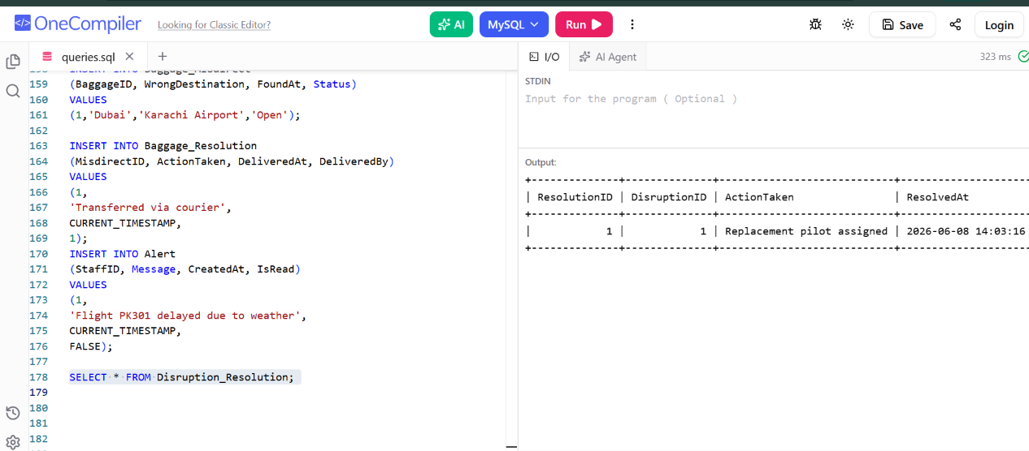

Feature 7 – Record Misdirected Baggage
INSERT INTO Baggage_Misdirect
(BaggageID, WrongDestination, FoundAt, Status)
VALUES
(1,'Dubai','Karachi Airport','Open');
SELECT * FROM Baggage_Misdirect;

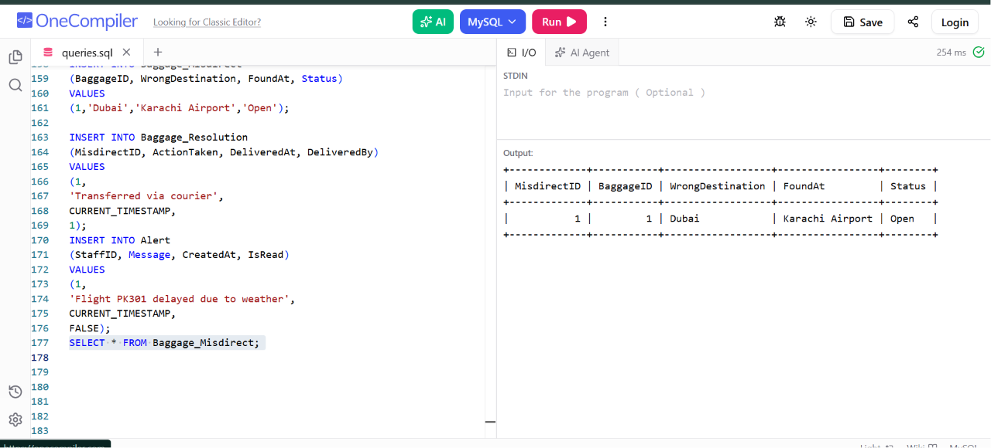

Feature 8 – Resolve Baggage Issue
INSERT INTO Baggage_Resolution
(MisdirectID, ActionTaken, DeliveredAt, DeliveredBy)
VALUES
(1,
'Transferred via courier',
CURRENT_TIMESTAMP,
1);
SELECT * FROM Baggage_Resolution;

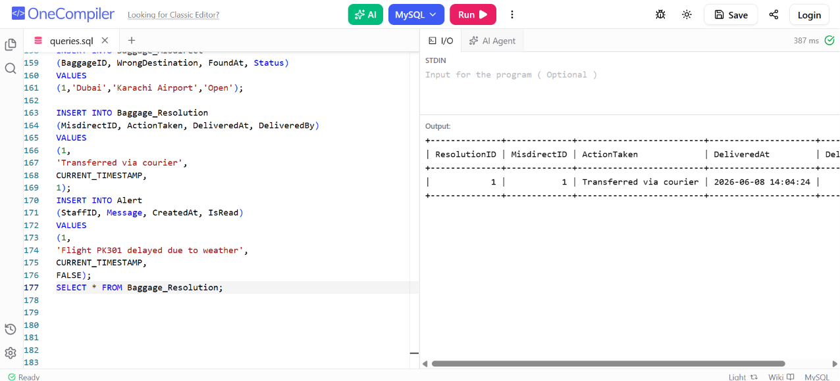

Feature 9 – Generate Alert
INSERT INTO Alert
(StaffID, Message, CreatedAt, IsRead)
VALUES
(1,
'Flight PK301 delayed due to weather',
CURRENT_TIMESTAMP,
FALSE);
SELECT * FROM Alert;

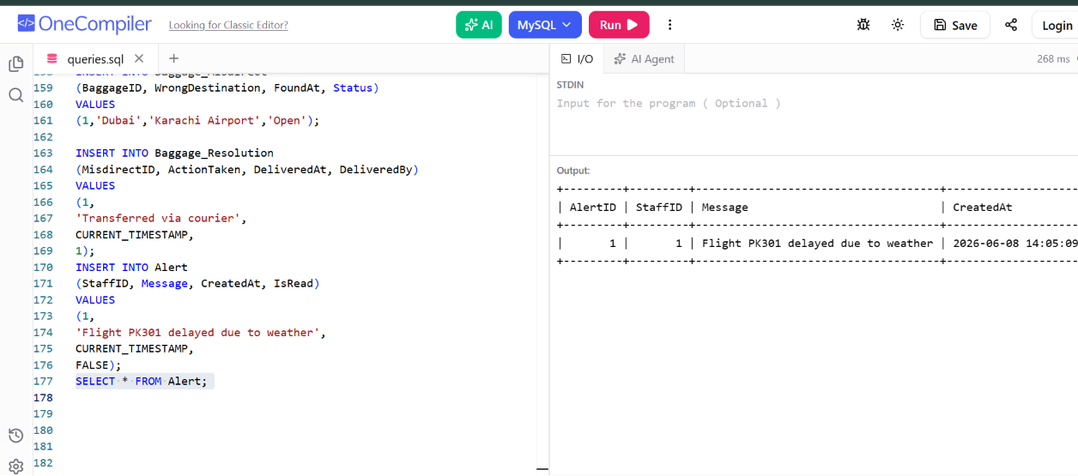

Feature 10 – View Open Disruptions
SELECT *
FROM Disruption
WHERE Status='Open';
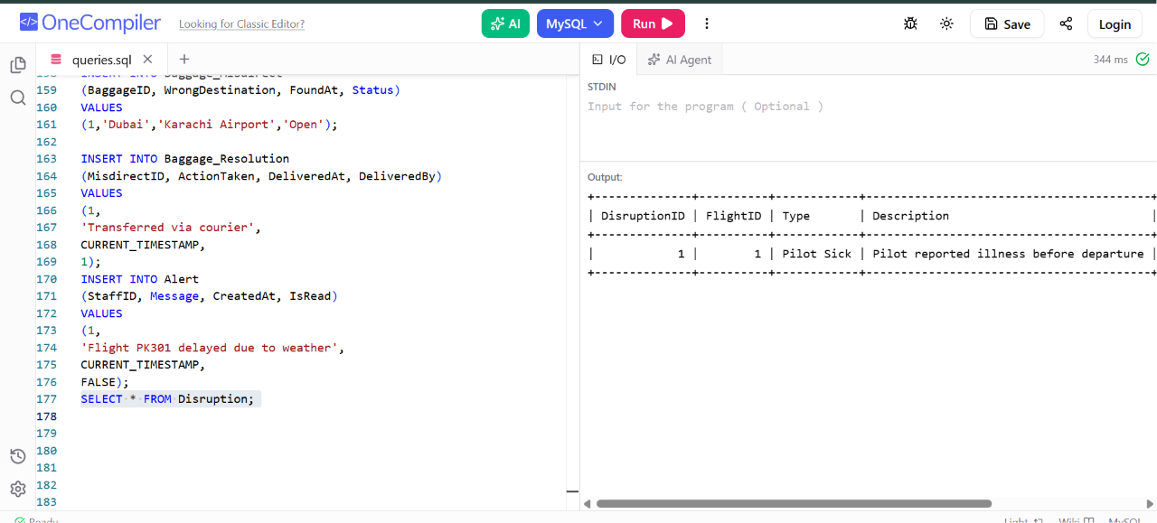

Update Flight
UPDATE Flight
SET Status = 'Delayed'
WHERE FlightID = 1;
SELECT * FROM Flight;
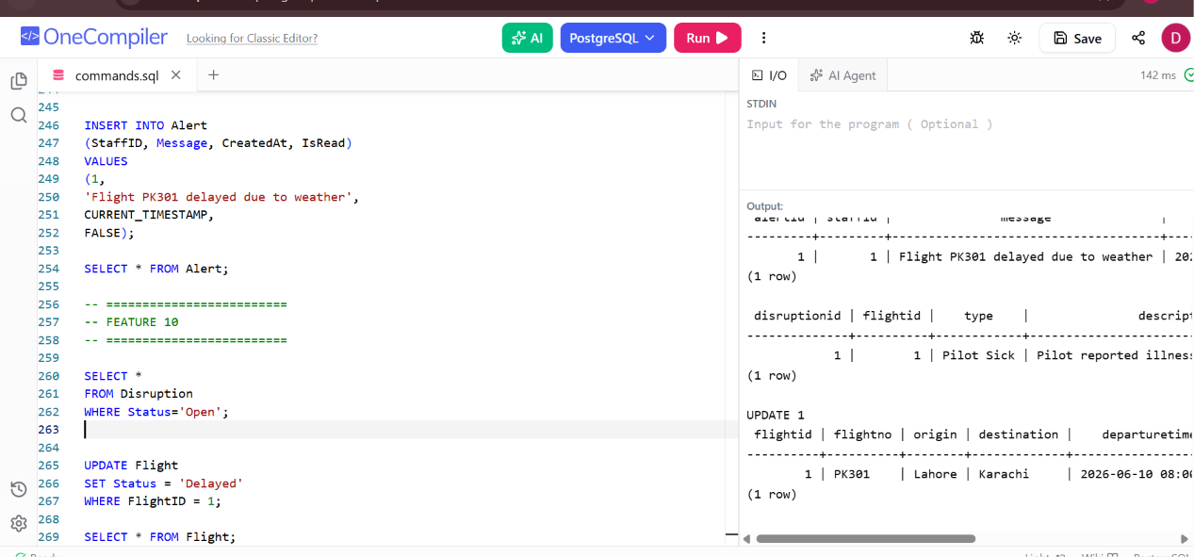

Delete Baggage_resolution

DELETE FROM Baggage_Resolution
WHERE ResolutionID = 1;

SELECT * FROM Baggage_Resolution;

